1. **Agenda**:
   1. Unit Testing JpaRepository.findId(Object);
2. 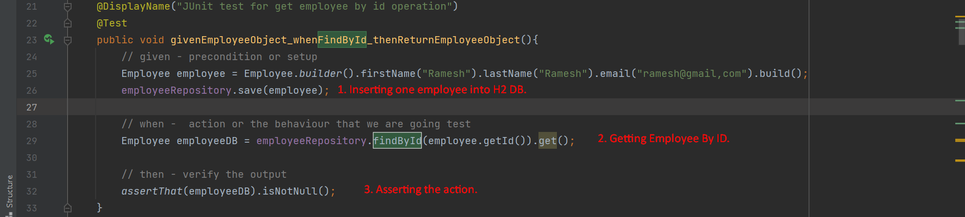
3. A screenshot of a computer

   Description automatically generated with medium confidence
4. 